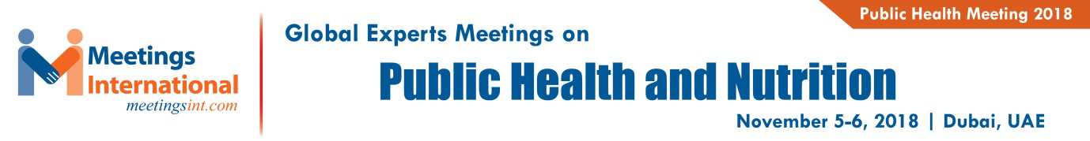

Abstract Acceptance Letter Date: August 28, 2018

To
Mehrshad Mehrkish,
Faculty of Veterinary Medicine, Azad University,
Babol, Iran
Meetings International cordially invites you to attend the “Global Experts Meetings on Public Health and Nutrition” to be held during November 5-6, 2018 in Dubai, UAE. We are glad to inform you that your abstract, entitled.”The effect of barberry and fumitory extract on growth performance, liver enzyme and seum lipid profile in broiler chickens ” has been accepted after peer review process by our editorial committee for “Oral presentation” at Public Health 2018. We invite you to join and appraise your knowledge on the theme “Enhance Publication Development towards Healthy Communication.
All accepted abstracts/papers will be published in the conference proceedings and supporting journals of Public Health 2018. The International Conference on Public Health and Nutrition has been initiated by the Editors of Journal of Clinical Nutrition and Metabolism; Journal of Food and Nutritional Disorders.

Kindly go ahead with the registration to confirm your participation.
https://www.meetingsint.com/healthcare-conferences/public-health/registration

We will look forward to see you in Dubai.

Regards,
Sophia Smith
Conference Coordinator | Public health meeting 2018
Meetings International Pte. Ltd.
28 Maxwell Road | #03-05 Red Dot Traffic
Singapore (069120)
P: +65-31-080-483
Toll Free: +800-852-6126

